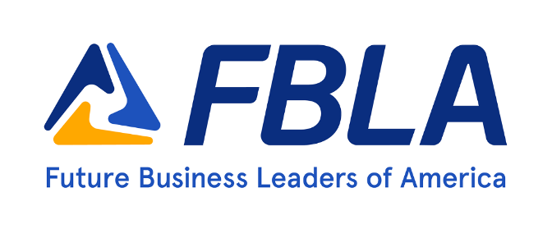

Welcome to FBLA (Future Business Leaders of America)!

We are excited to have you on our team. As we gear up for the new academic year, we wanted to take a moment to welcome both new and returning members to CHAPTER NAME Future Business Leaders of America (FBLA)!

FBLA is a national organization that aims to inspire and prepare students for leadership roles in the business world. Our chapter at YOUR SCHOOL High School is dedicated to providing opportunities for our members to develop their business skills, network with other like-minded individuals, make lasting friendships, and give back to our community.

We are excited to announce that this year, we have planned a variety of events and activities that will help our members grow both personally and professionally. From guest speakers to workshops, social events, community service projects to competitions, there will be something for everyone.

As an FBLA member, you will have access to a network of students and professionals who share your passion for business. You will also have the opportunity to attend district, state, and national conferences, where you can compete against other FBLA members from across the country.

We encourage all of our members to get involved and take advantage of everything that FBLA has to offer. Whether you're interested in entrepreneurship, finance, marketing, or you know nothing about business and you just want to be a part of our team, there's a place for you in FBLA.

We look forward to working together to make this year a success and we are so ecstatic to have you competing with us.

Let’s make this our best year yet!

Sincerely,

CHAPTER PRESIDENT

FBLA Membership Requirements:

Complete the following, initial each box, and return to LEAD ADVISER BY DATE to become an official member of FBLA:

Communications:

* Join FBLA’s Google Classroom–Code: OR ESTABLISH OTHER COMMUNICATION CHANNEL
* Have your parents join the Parent Remind group by (INFO HERE ABOUT PARENT COMMUNICATION CHANNEL)

Personal Information:

* Fill out the Registration form completely and accurately.

Release Forms:

* Multiple Release Form
* Transportation Release Form
* Emergency Contact Form
* Code of Conduct

Fees:

* Pay $75 (OR YOUR SUM) which includes National, State, & local Dues, District Leadership Conference Registration, and an FBLA Shirt (cash or check payable to RHS)
* PAYMENT METHODS HERE:

2024-2025 Cost Breakdown:

Amounts listed are estimated costs and are subject to change. Students can greatly reduce out of pocket costs by participating in fundraising opportunities and by finding corporate sponsors. Money raised through our other fundraisers and through sales in the Exchange Store/Trailer will be distributed to students who volunteer throughout the year. **If students choose not to volunteer, they will be responsible to pay for their own nationals trip.**

Dues & District Leadership Conference (LOCATION AND DATE): $75

* $20 National, State & Local dues
* $35 District Leadership Conference Registration
* $20 Shirt

State Leadership Conference (Gaylord Hotel, Aurora): $360

* Registration
* Housing (4 per room)
* Entertainment
* T-Shirt
* Food

National Leadership Conference (Anaheim, CA): $1400-$1600

* Registration
* Housing (4 per room)
* Transportation (Airfare & Ground)
* Entertainment (possible: museum, baseball game, etc)
* Food
* Disneyland or Universal (not included)

Other Costs:

* Social events
* Meals during field trips or other activities
* Providing snacks to share for meetings from time to time

*Scholarships are available in the case of financial hardship. Talk to LOCAL ADVISER.